**Spiritual Self-Evaluation**

in order to increase your awareness of God’s presence and work in your life, you need to take inventory of your spiritual life.

Write a short description of your spiritual life during various periods of time.

When did you first think about God? What was your life like from the standpoint of virtue, strengths, or weaknesses? Remember that these are just the highlights (we are not looking for a complete autobiography). Once you complete this “rearview mirror” look at your life, move into the present and begin by asking yourself what has triggered your current interest in spiritual direction or the desire to move deeper into your relationship with God.

If this is still feeling a bit vague, the following diagram and description of the process may be helpful.

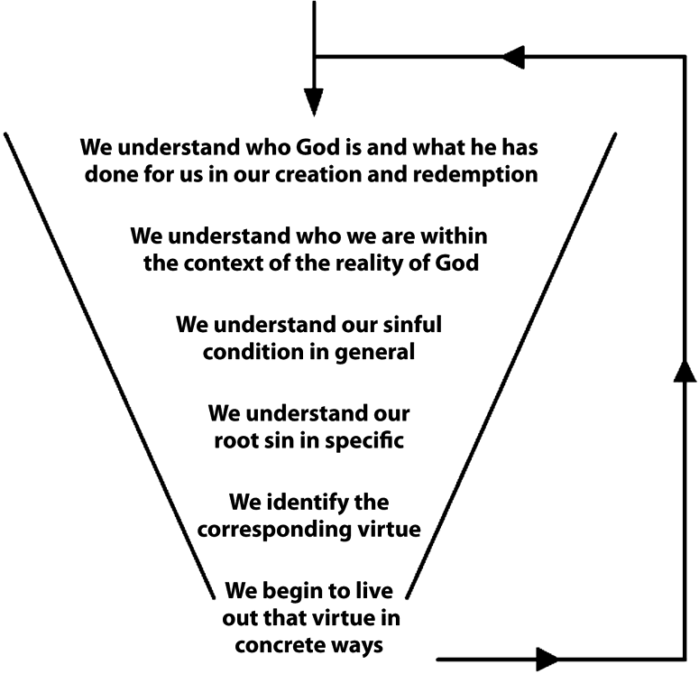

**My Sacramental Preparation**

What is the frequency of my participation with sacraments of the Church and other aspects of worship?

|  |  |  |  |  |  |  |
| --- | --- | --- | --- | --- | --- | --- |
|  | **Daily** | **Weekly** | **Monthly** | **Quarterly** | **Annually** | **Other/Don’t Know** |
| **Eucharist/Mass** |  |  |  |  |  |  |
| **Adoration** |  |  |  |  |  |  |
| **Confession** |  |  |  |  |  |  |

***My Prayer Life***

What is the state of my prayer life?

|  |  |  |  |  |  |  |
| --- | --- | --- | --- | --- | --- | --- |
|  | **Daily** | **Weekly** | **Monthly** | **Quarterly** | **Annually** | **Other/Don’t Know** |
| **Vocal Prayer (Rosary, other formula prayers)** |  |  |  |  |  |  |
| **Mental Prayer (you use your own words to pray)** |  |  |  |  |  |  |
| **Examination of Conscience** |  |  |  |  |  |  |
| **Other** |  |  |  |  |  |  |

What form(s) of prayer do I enjoy most and why?

What form(s) of prayer do I struggle with the most and how?

Do I struggle with prayer in general? If yes, in what way(s)?

***My Spiritual/Intellectual Development***

What is the state of my spiritual reading or intellectual development of my faith?

|  |  |  |  |  |  |  |
| --- | --- | --- | --- | --- | --- | --- |
| **I read** … | **Daily** | **Weekly** | **Monthly** | **Quarterly** | **Annually** | **Other/Don’t Know** |
| **Scripture** |  |  |  |  |  |  |
| **Spiritual books** |  |  |  |  |  |  |
| **Theological, apologetics/other Catholic materials** |  |  |  |  |  |  |

**What is your root sin? Don’t try to be perfect in this exercise. You just need to know your general tendency which is stronger than other sins.**

**Root Sin of Pride**

Pride: Excessive love of one’s own excellence or desired excellence. Pride manifests itself when we seek our self-worth and security in our own abilities, traits, or strengths

|  |  |  |  |  |
| --- | --- | --- | --- | --- |
| **Never** | **Sometimes** | **Frequently** | **Focus** | **Manifestations of the Root Sin of Pride**  *1st Review: Move quickly and assess by instinct. If you hesitate, go with your first instinct*.  *2nd Review: Review items checked in Sometimes or Frequently categories. Determine manifestations that require attention and identify them in Focus column with a checkmark*. |
|  |  |  |  | too high an opinion of myself or an elevated concept of myself |
|  |  |  |  | annoyance with those who contract me or question what I say |
|  |  |  |  | inability to submit to those who I judge as less competent or less spiritual than I am |
|  |  |  |  | refusing or resisting assent to others without a satisfactory explanation |
|  |  |  |  | anger if I don’t get my way or am not taken into account |
|  |  |  |  | easily judgmental, putting others down, gossiping about them |
|  |  |  |  | slow to recognize or acknowledge my own mistakes or weaknesses |
|  |  |  |  | slow to see when I hurt others and inability to seek and give forgiveness |
|  |  |  |  | frustration or anger when others don’t thank me for favors or work that I do |
|  |  |  |  | unwillingness to serve, rebellion against what I don’t like or agree with |
|  |  |  |  | impatience, distance, brusqueness in my daily contact with others |
|  |  |  |  | thinking I am the only one who knows how to do things right |
|  |  |  |  | unwillingness to let others help me or advise me |
|  |  |  |  | inflated idea of my own intelligence and understanding |
|  |  |  |  | dismissing what I do not understand or what others see differently |
|  |  |  |  | not feeling a need for God, even though I do say prayers |
|  |  |  |  | nursing grudges, even in small matters |
|  |  |  |  | never taking orders or bristling when orders are given to me |
|  |  |  |  | inflexible in preferences or perspective |
|  |  |  |  | always putting myself and my things first |
|  |  |  |  | indifference towards others and their needs, never putting myself out for them |
|  |  |  |  | centering everything (conversation, choices, recreation, etc.) on myself and my likes |
|  |  |  |  | calculating in my relations with God and with others |

Notes:

**Root Sin of Vanity**

Vanity: Excessive concern for and seeking our security in how we are perceived (what others think about us)

|  |  |  |  |  |
| --- | --- | --- | --- | --- |
| **Never** | **Sometimes** | **Frequently** | **Focus** | **Manifestations of the Root Sin of Vanity** *1st Review: Move quickly and assess by instinct. If you hesitate, go with your first instinct*.  *2nd Review: Review items checked in Sometimes or Frequently categories. Determine manifestations that require attention and identify them in Focus column with a checkmark*. |
|  |  |  |  | always seeking admiration and praise, worrying about not getting it |
|  |  |  |  | excessive concern about physical appearance |
|  |  |  |  | dedicating excessive time to “primping” one’s person or possessions |
|  |  |  |  | hoping “I am the best” and finding ways to get others to think so |
|  |  |  |  | being guided by the opinions of others rather than principle |
|  |  |  |  | some types of shyness out of fear of not being liked/accepted by others |
|  |  |  |  | sacrificing principles in order to fit in |
|  |  |  |  | placing too high a premium on popularity and acceptance |
|  |  |  |  | easily discouraged at my failures |
|  |  |  |  | hypocrisy or two-facedness in order to be accepted |
|  |  |  |  | taking pleasure in listening to gossip |
|  |  |  |  | taking pleasure in hearing about or speaking about others’ failures or misfortunes |
|  |  |  |  | breaking confidences |
|  |  |  |  | stretching the truth or outright lying to be admired or to hide shortcomings |
|  |  |  |  | severe disappointment when others don’t appreciate my ideas or possessions |
|  |  |  |  | always wanting to be the center of attention, at times stretching the truth or lying outright, or being uncharitable in my words in order to achieve this |

**Root Sin of Sensuality**

Sensuality: seeking our security and self-worth in possessions, comfort, or the avoidance of discomfort (real or perceived).

|  |  |  |  |  |
| --- | --- | --- | --- | --- |
| **Never** | **Sometimes** | **Frequently** | **Focus** | **Manifestations of the Root Sin of Sensuality**  *1st Review: Move quickly and assess by instinct. If you hesitate, go with your first instinct*.  *2nd Review: Review items checked in Sometimes or Frequently categories. Determine manifestations that require attention and identify them in Focus column with a checkmark*. |
|  |  |  |  | laziness |
|  |  |  |  | always seeking comfort, that which requires the least effort |
|  |  |  |  | not going the extra mile for others |
|  |  |  |  | procrastination, last minute in everything |
|  |  |  |  | shoddiness, complaining, excessively affected by minor discomforts |
|  |  |  |  | inability to sacrifice |
|  |  |  |  | not doing my part at home |
|  |  |  |  | always expecting everyone else to serve me |
|  |  |  |  | behavior and decisions ruled by my feelings and moods instead of my principles |
|  |  |  |  | daydreaming a lot with self at the center |
|  |  |  |  | unable to control my thoughts when they attract me, even when they are not good |
|  |  |  |  | doing or partaking in only what I enjoy (food, drink, work, etc.) |
|  |  |  |  | allowing what I enjoy or prefer to push out what I should do |
|  |  |  |  | uncontrolled curiosity, wanting to see/experience everything |
|  |  |  |  | senses and impulses overrule what I know is right and wrong |
|  |  |  |  | acting out feelings (frustrations, desires, etc.) with no regard for God or others |
|  |  |  |  | only working with those I like, being easily hurt |
|  |  |  |  | fickleness and inconsistency |
|  |  |  |  | unable to stay on track without constant supervision |
|  |  |  |  | can never finish what I start |

A lived relationship with Christ brings the greatest love, joy, and peace that can be known in this life

“In the world you have tribulation; but be of good cheer, I have overcome the world” (Jn. 16:33).